**TECHNICAL PROPOSAL**

**Ministry of Economy**

Website & Service Redesign

Submitted By:

VERBANET TECHNOLOGIES L.L.C

**CONTENTS**

**0KEY DETAILS** 4

**1** **COMPANY PROFILE** 5

**2** **SIMILAR PROJECTS** 6

**3** **EXECUTION TEAM** 7

**4** **PROJECT SCOPE** 8

4.1 PROPOSED SOLUTION MODEL 8

4.2 FUNCTIONAL REQUIREMENTS 8

4.3 NON-FUNCTIONAL REQUIREMENT (OTHERS) 11

4.4 PROPOSED SYSTEM ENVIRONMENT 12

4.5 TECHNICAL CONFIGURATIONS 13

4.6 PROJECT DELIVERY 14

4.7 PROJECT ASSUMPTIONS 19

**5** **OUT OF SCOPE** 21

5.1 CHANGE MANAGEMENT 22

5.2 MAINTENANCE & SUPPORT 24

5.3 SERVICE LEVEL AGREEMENT (SLA) 24

**6** **TERMS & CONDITIONS** 26

6.1 ACCEPTANCE CRITERIA 26

6.2 WARRANTY 26

6.3 SOURCE CODE & INTELLECTUAL PROPERTY RIGHTS 26

6.4 GENERAL TERMS AND CONDITIONS 27

6.5 GENERAL ADMINISTRATIVE, TECHNICAL & FUNCTIONAL ASSUMPTIONS 28

**7** **FINANCIALS** 30

7.1 WEB AND MOBILE APPLICATION DEVELOPMENT 30

7.2 WINDOWS DEDICATED HOSTING – OPTIONAL 31

**8** **CLIENT REFERENCES** 32

**9** **ABOUT US** 36

# **0KEY DETAILS**

**PROJECT NAME CLIENT**

Corporate Social Innovation Hub Sustainable Square

**CLIENT CONTACT CLIENT ADDRESS**

Mr. P.O.Box 123

ABC Street

Dubai

U.A.E

**PROPOSAL SUBMISSION PROPOSAL ID NO.**

06.07.2020  AD/BP/25042018/1820/2

**PROPOSAL VALID UNTIL ANTICIPATED START DATE**

10.08.2020 00.00.00

**PROPOSAL SUBMITTED BY PROPOSED TECHNOLOGY**

Verbanet Technologies L.L.C ASP.NET Dubai, U.A.E **APPLICATION TYPE**

+971 4 297 3236 Web & Mobile Application

+971 50 765 2345

# **EXECUTIVE SUMMARY**

This proposal is 2 part and addresses the concerns raised in the RFP’s issued by the Ministry of Economy. Namely

* Phase 1: Design and engineering of Ministry of Economy digital touchpoints: redesign website and deploy a compatible CMS that supports the redesigned website
* Phase 2: Ministry of Economy digital service design – Redesign services and develop mobile application

As we understand the two RFP’s are tightly coupled. One being the redesign of the UI in a manner that is more user friendly and relevant to the technological landscape. The other requirement being the development of a scalable web application that integrates with the various third party entities that interact with the ministry of Economy.

Aside from the above, the proposal also bears in mind the need for a hybrid mobile application that can be deployed in on both IOS and Android devices. The mobile application shall furnish all of the services addressed by the web application.

The RFP has clearly indicated the requirement for a scientific approach in the decisions taken to re-design and develop the UI/UX of the said web application. This document shall illustrate Verbat’s commitment to the design and development of the website, its services and integration with third party components. To summarize, we hope to convince you that, Verbat is fully capable of servicing all your needs. Namely,

1. Our approach to UI/UX design and how we can support the ministry in designing and developing elegant interfaces that are relevant and appealing to its users
2. Our evaluation of comparable CMS products that shall help the ministry in making wise and informed choices.
3. Our approach to builds and releases. The document shall give a preview of our capabilities in the automation of builds and releases
4. Our capability and approach to functional, integration and automated testing
5. The list of deliverables to be expected.
6. Last but, not the least, our project implementation methodology, support plans etc.

# **STATEMENT OF WORK**

Ministry of Economy (hereafter referred to as “Client”) has floated RFP’s to redesign the UI/UX of their existing website as well as the services provided by the web application. The redesign includes the deployment of a compatible and scalable CMS that supports rapid change. This document is Verbanet Technologies L.L.C., (hereafter referred under its trade/brand name as” Verbat”) response to the RFP’s raised by the client.

### Goals: MOE Web Site & MOE Services

#### **Phase 1: Web Site**

* Increase usage and satisfaction of MOE digital touchpoints
* Redesign MOE web portal following modern web and mobile design and development standards in user experience, performance and information architecture in order to provide a better experience to MOE stakeholders.
* Provide benchmarking and ideation on new features, experience cues, and technologies that would help achieve the aforementioned objectives.
* Provide a reliable and secure environment for MOE customers to conduct financial transactions online through our web platform.
* Rethink and redesign all digital services provided by MOE currently into a modern experience design.

#### Phase 2: Web Services

* Increase usage and satisfaction of MOE digital services
* Increase usage of online services
* Decrease the lead time (# of steps, information required, etc.) of using MOE digital services.
* Decrease operational cost to serve on the selected services
* Provide an Omni-channel experience online and offline for MOE customers
* Provide a service design blueprint for future service building showcasing points of data collection/processing, clear data architecture, customer touchpoints and service
* Provide a reliable and secure environment for MOE customers to conduct financial transactions online through our web platform.
* Provide a reliable web service/APIs infrastructure that can be tied up to other touchpoints such as e-government service kiosks, transaction offices, mobile services/apps, and more.
* Re-design digital services to decrease lead time and improve overall experience of MOE customers

***In the rest of the document, Phase 1 implies web site redesign while phase 2.1 implies Services redesign. Phase 2.2 refers to mobile development.. Phase 2.1 and 2.2 development shall be conducted in parallel.***

### Scope

#### Phase 1: Website

Verbat shall redesign and develop a new web platform with a modern CMS that supports rapid application and deployment of content changes, test concepts, and continuously improve customers’ online experience while maintaining data and information integrity.

The redesign process shall ensure the conviction of all key stakeholders at MOE, follow the guidelines provided by TRA on accessibility, security, and any further design or engineering requirements. The redesign and engineering process shall take into consideration the TRA guidelines on smart government criteria and feedback collection.

The redesign process shall lay out the MOE target audiences and the approach that Verbat shall consider to ensure that MOE stakeholders remain engaged and informed.

Verbat shall continue to engage with MOE in Phase 2 of the project – to integrate and deploy services onto the web application. All back end services created for CMS shall be API based so that they can be reused by the mobile applications

#### Phase 2: Web services

The client shall provide a blue-print and low fidelity wireframe of the new services that are to be implemented. Verbat shall work with the client’s team on incorporating the designed services into the content management system

### Functional Requirements

#### Phase 1: Website

**Website Design Requirements**

1. Conduct discovery workshops with key IT and communications stakeholders at MOE to uncover insights and build consensus on design language and information architecture.
2. Conduct customer interviews (minimum of 5) to generate actionable insights on the user experience
3. Document and present findings along with (3 low fidelity UX concepts) that lays out the main experience stages
   1. Ensure that the new designed service improve customer experience (Reduced steps, cleared information architecture, improved conversion, improved data collection, etc.) by conducting rapid prototyping and user testing.
   2. Provide extensive documentation and acquire the required approval on the service redesign including service description, backend workflow, flowcharts, prototype and use cases.
4. Design the approved experience into a consistent User Interface and acquire the needed approvals. The UI shall follow MOE brand guidelines and modern web and mobile Human-Interaction guidelines. (2 UI options of key templates will be required for design sign off)
   1. The design should follow a mobile-first, Arabic-first approach.
   2. Verbat shall provide a UI kit for future changes and frontend-related development
   3. Verbat shall take into consideration various use cases such as RTL/LTR, empty state, filled state, advanced filtration, sorting, search, and notifications (errors, success, failure, etc.).
   4. The website shall follow the TRA Guidelines for Government Websites. Website development and design, including branding, shall be fully compliant with the UAE Federal Government Web Guidelines and federal government evaluation standards and criteria.
   5. The platform shall be built using modular components
   6. The solution architecture shall address scalability requirements, in terms of both application (to add new services) and infrastructure

**Website & CMS Features**

1. Integration with UAE Pass in order to use Emirates ID to automate any step and/or reduce data entry from customer side and/or staff side
2. Ability to retain customers entered data (Save as draft). The saved drafts should be accessible to user upon logging into the system and should be retained indefinitely.
3. All service requests should have an auto-fill component based on previous entries or user profile information.
4. All service requests need to happen above the fold (no scrolling should require) with each step visible to the user at all times. The platform shall provide consistent validation feedback to the user on required fields or incorrect fields.
5. The user shall be able to view documents inside the page using a Document Viewer without having to download the intended documents. (See assumptions)
6. All web forms shall include anti-spam/anti-abuse measures such as Google CAPTCHA.
7. The CMS shall have advanced personalization to allow content targeting for different user segments. (See assumptions)
8. The CMS should have an advanced form builder to allow rapid form creation and data collection. (See assumptions)
9. Migrate all the current website content and functionality: Vendor must study the existing website and migrate the users and data to new website. Also, they are expected to build the appropriate screens for the users to access the data in the new website.

**Website Integrations**

1. UAE Pass for user authentication and profile creation (Optional to the user)
2. Zendesk Support
3. Transaction Email service (Mail gun, Twilio Sendgrid, etc.)
4. Transactional SMS service
5. Ministry of Finance e-dirham for payments
6. Integrate with KHADAMATI Portal to get and push all service cards through coordination with PMO via MOE channels
7. Implement e-participation module as per TRA Guidelines.

**Other Requirements**

1. Verbat shall supply the source code of the site and any licenses shall be the property of MOE. Verbat shall also supply the client team with complete documentation.
2. Provides a site analytics tool with a 3-year license to discover site statistics like broken links, visits, etc. ( See assumption)
3. Open data section structure to be developed. Data should be actively and automatically updated. Compliance with benchmarked with data.ae or Dubai pulse. (This requirement is unclear, Verbat shall clarify any implementation concerns during system study)
4. Incorporate analytics for website usage tracking and identify users experience and actions ( See assumptions on site analytics)
5. Technical Requirement Study, Development of website including data preparation, data migration, module testing shall be provided
6. Performance & Usability Testing to be tenaciously completed and documented. ( See assumptions)

**CMS Capability Requirements**

**Content Creation and Editing**

1. The CMS support content editing, including support for rich text with HTML and style (CSS) enforcement.
2. The CMS support creating multi-lingual content without need to duplicate the content item. ( See assumptions)
3. The CMS provide the ability to create and maintain dynamic forms (ex: contact us, ask question, etc.) to collect information from users, and reuse these forms throughout one or multiple pages. (Please note that this depends on the capability of the CMS used)
4. The CMS provide the ability to create and maintain shared assets that are used throughout one or multiple websites. ( see assumptions)
5. The CMS provide out-of-the box ability to edit the pages content; no technical expertise should be needed.
6. Users can search to find existing reusable content. (Typically reusable content is available based on context)
7. The CMS provide common “library services” including check in and out, revisions and versions (Version History with Rollback) – ( see assumptions)
8. The following content types should be supported out-of-the-box: Rich Text, Plain text, HTML, Image, File (PDF/Word/Excel/etc.), Calendar Events, Video, and Structured Content.
9. The CMS support editing of metadata by content contributors, including structured information such as publication and expiration dates, etc.

**Social Media**

1. The CMS can display external social media content.
2. The CMS allow external RSS feeds automatically to be displayed in the site pages, an integration link if required. (ex: RSS from WAM.ae) ( see assumptions)
3. The CMS allow comments to be used on any site page.
4. The CMS provide the ability to generate polls. (depends on the CMS platform)
5. Search Engine Optimization (SEO)
6. The CMS ensure that Page Title, Page Summary and other critical SEO elements can be created even by casual content contributors.
7. The CMS provide the ability to create SEO-Friendly URL.
8. The CMS provide marketers the ability to create URL-redirects.

**Design and Templates ( see assumptions)**

1. The CMS provide a page building and layout environment where users can select or drag and drop from a palette of page elements to change page designs.
2. The CMS provide the capability to apply different layouts/templates on any of the website levels. (ex: section level or single page level).
3. Develop content templates for articles, case studies, videos, webinars, podcasts, or more (Determined in the workshop).

**Navigation**

1. The CMS provide a capability to maintain site navigation.
2. The CMS provide out-of-the-box breadcrumb capabilities to include in the website. (Bread crumb capability will most likely require customization)
3. The CMS provide support for mega-menus. ( assuming these are the main menus in the application)

**Roles and Users**

1. CMS supports out-of-the box integration with Windows authentication based on Lightweight Directory Access Protocol (LDAP)
2. Ability to create custom roles and associate users to roles through an easy-to-use administrative interface.
3. Ability to create custom permission and assign it to a given role.
4. Ability to assign multiple roles to a given user.

**Workflow (See assumptions) and Governance**

1. Ability to define workflows through an easy-to-use administrative interface.
2. The workflow includes the ability to determine which roles have access to perform which actions at each step of the workflow.
3. The CMS automate notification to users and roles when there is content for review.
4. The CMS can schedule a page/content to go live and expire (come down from the site).
5. The CMS provide a full revision history of changes made and who performed them.
6. The CMS allow older versions of content to be promoted to the live site.
7. The CMS provide validation on content and metadata, such as required fields or allowable types of content by field (e.g. only email in an email address field).
8. The CMS provide out-of-the box tool to bulk upload media content such as files and images. ( See assumptions)
9. The CMS provide a preview function so users can see page content before it is approved.

**Environment and Architecture**

1. The CMS will be hosted on windows environment.
2. The CMS must be based on .Net CORE framework.
3. The CMS must support high availability deployment.

**Key Website Modules that shall be developed by Verbat**

1. Service Directory (which will list MOE Services with a dedicated service card page for each service)
2. Laws and regulations
3. E-Services
4. News Highlights
5. Events Calendar
6. Photo & Video Gallery
7. Open Data
8. Survey & Polls
9. Careers Module
10. Complaints and suggestions
11. Social Media Integration
12. Advanced Search
13. FAQs
14. Social Media Hub
15. Media Kit
16. Accessibility Options
17. Google Analytics
18. SEO Friendly Features
19. Contact Us
20. E-Complaints and customer feedback.

**Mobile App Requirements**

* The mobile app needs to replicate the website experience in less depth but should provide the same end goal for every customer. ( see assumptions)
  + The app should have consistent experience across all form factors and operating systems.
* Verbat shall deliver a hybrid mobile app with an omni-channel experience to customers regardless of their touchpoint. The mobile application shall deliver on the following:
  + Backend: The application shall share the same backend as the website to allow real-time updates on all content and services being updated.
  + Frontend/OS Language: The app shall be developed in cross-platform language such as React Native with high-availability and stability. The app should be available in both iOS & Android.
  + Allow for basic mobile privileges such as local storage, upload from camera/storage, push notifications, location services (for services section), download documents, push notifications, and any other key functionality uncovered during the discovery phase.

**Required Functionality:**

1. Authentication: The customers shall be able to access their accounts using UAEPass or MOE user account.
2. Customers shall be able to access and apply for all services (Searchable service directory) (See assumptions on mobile app features).
3. Browse and consume content in blog, news, articles, case studies, OpenData, and any other form of content presented on the website. ( There may be limitations to the types of content that can be consumed by the mobile app because of various reasons such as screen real estate, sixe of content, view ability etc)
4. User dashboard: access the same information presented on the website dashboard, updates in real-time.
5. Locate service centers of MOE using Google Maps services
6. Service payments through integration with E-DHS
7. Access FAQ and contact support through chat or submitting requests (The contact center application will be determined during discovery. ex: ZenDesk)
8. Adjust account information or settings
9. Share content or the app through several sharing platforms such as WhatsApp, Facebook, Twitter or Email

**Mobile App Integrations:**

1. The mobile app will need to be integrated with the website CMS to reflect in real-time services and content
2. UAEPass & MOE Authentication services.
3. E-DHS Payments Gateway.
4. Customer Service Platform (Chat & Support Tickets).
5. Integration with Qmatic system to display list of services per center and create token ticket.

## Technical-Functional understanding of the proposal

### Website Features

### UI/UX design Principles

### Information Architecture (Site map exploded)

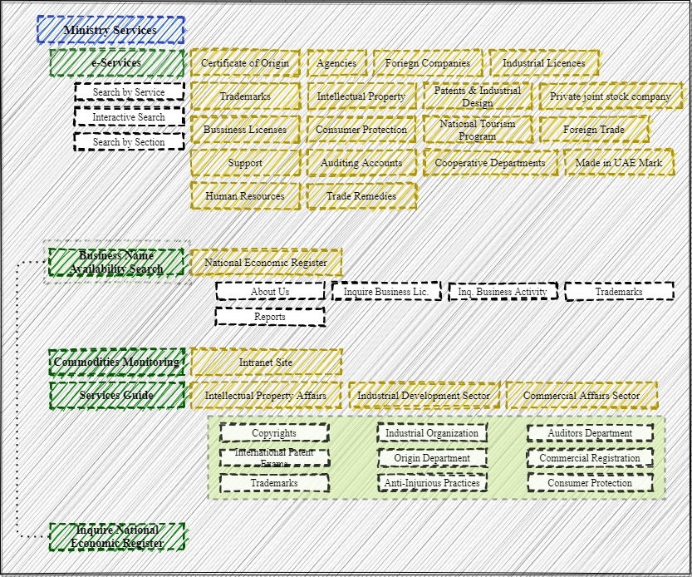

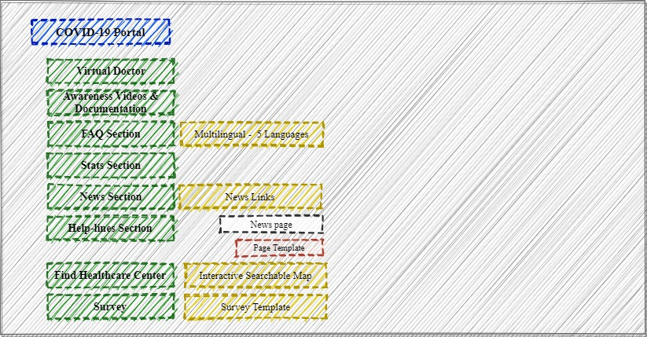

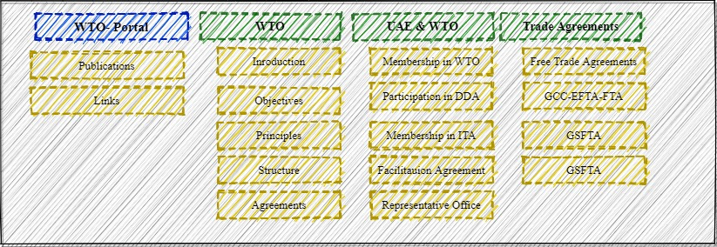

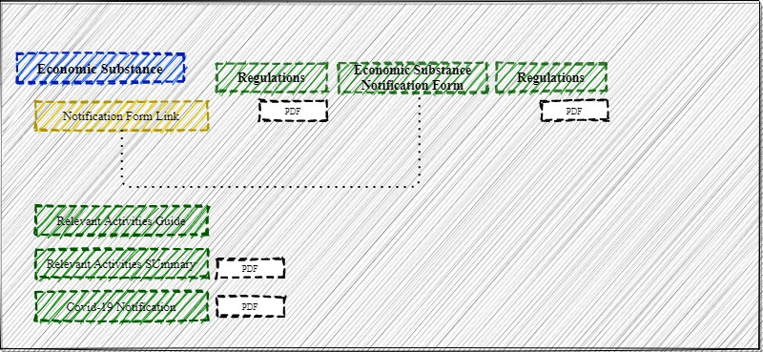

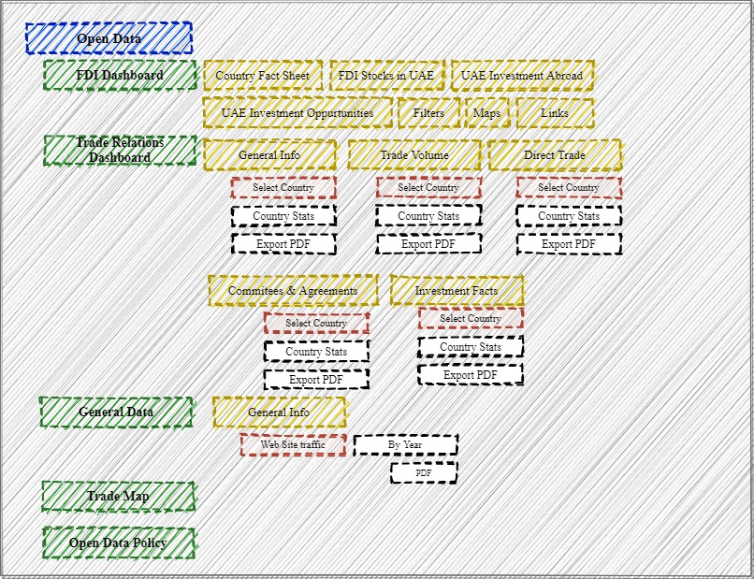

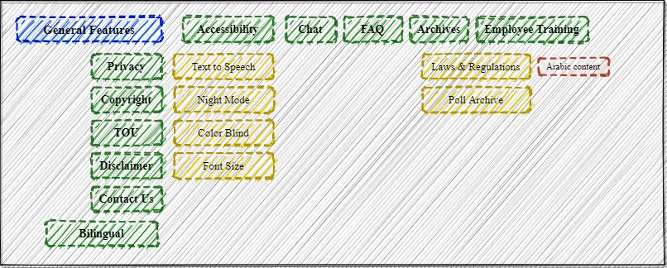

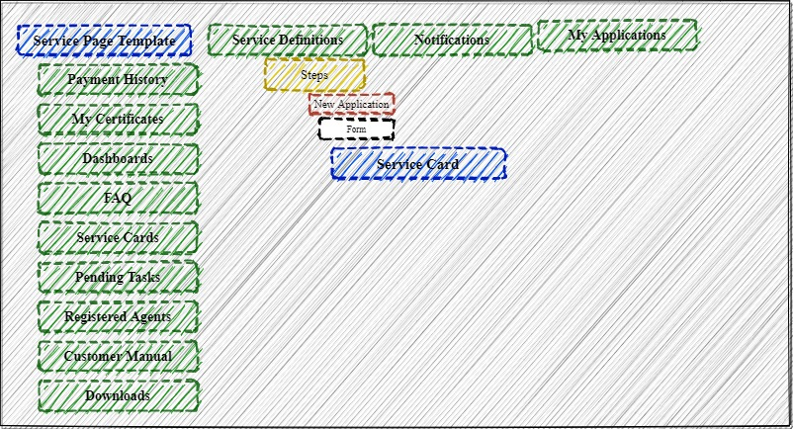

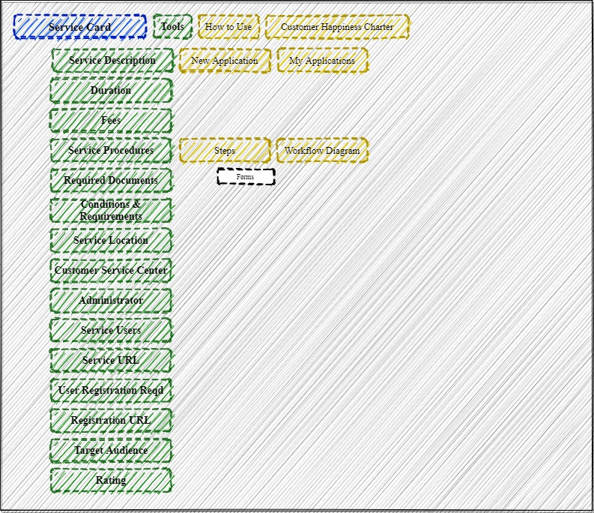

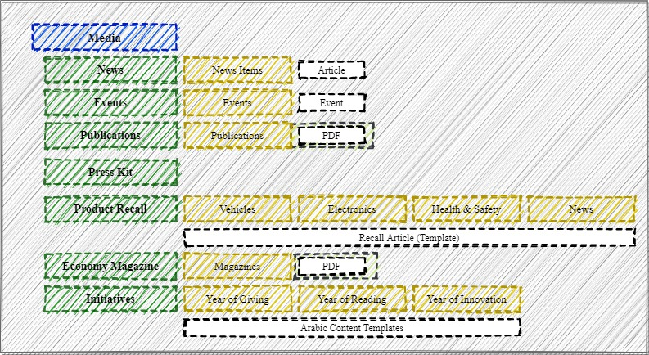

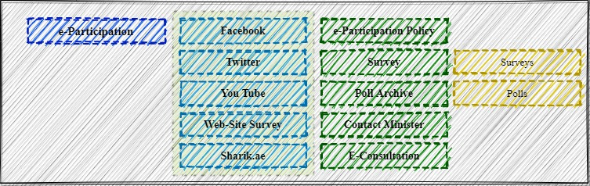

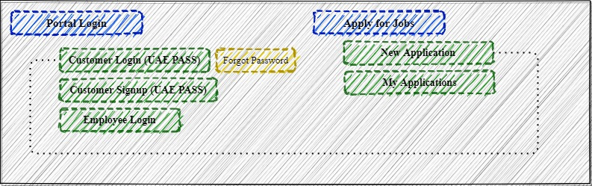

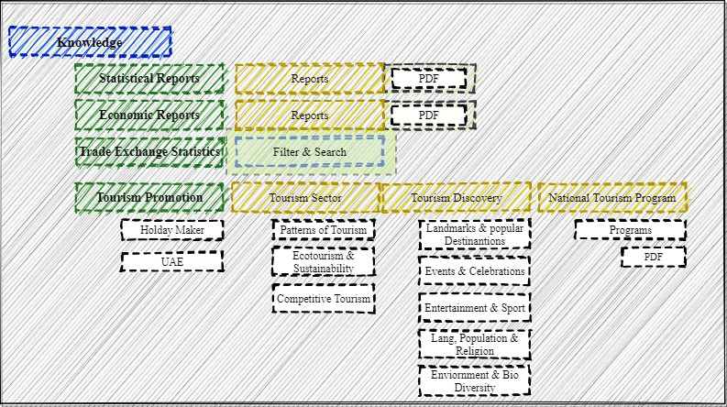

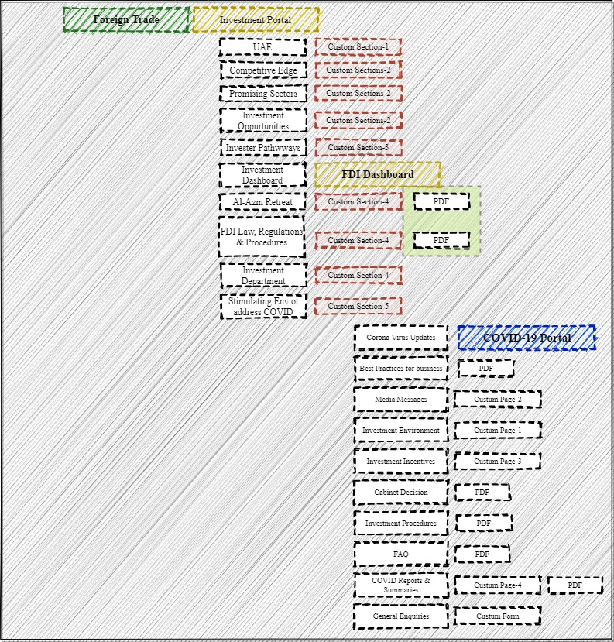

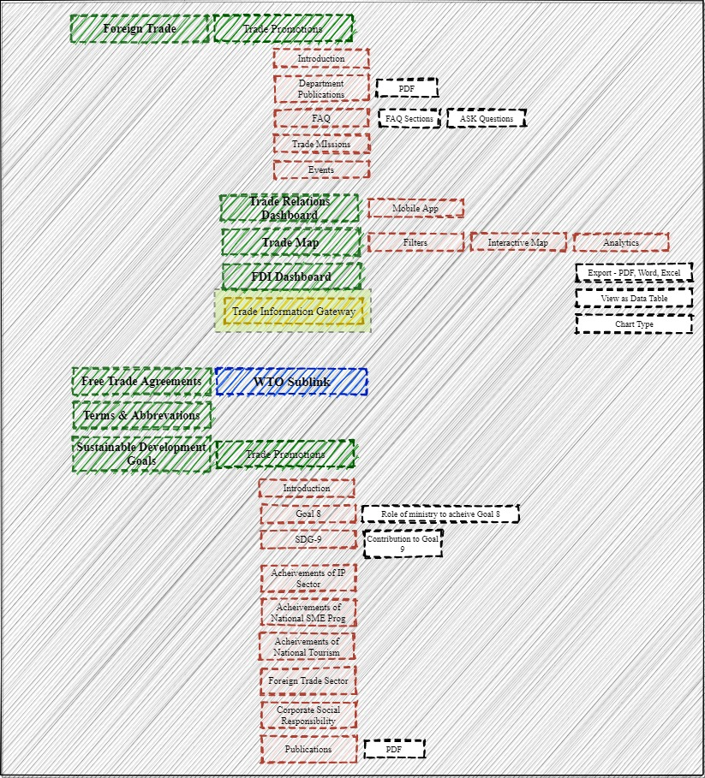

### Tentative Information architecture

### Actual form design & workflow design screens from a popular Open source CMS

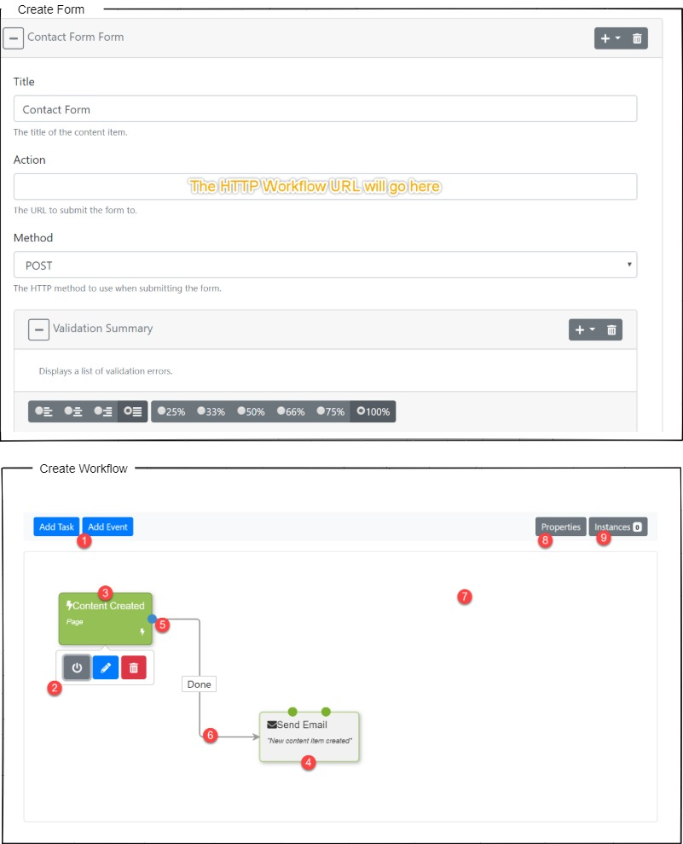

### CMS Modules considered for development in this proposal

### Functional Architecture for the CMS Platform

### Development Stack

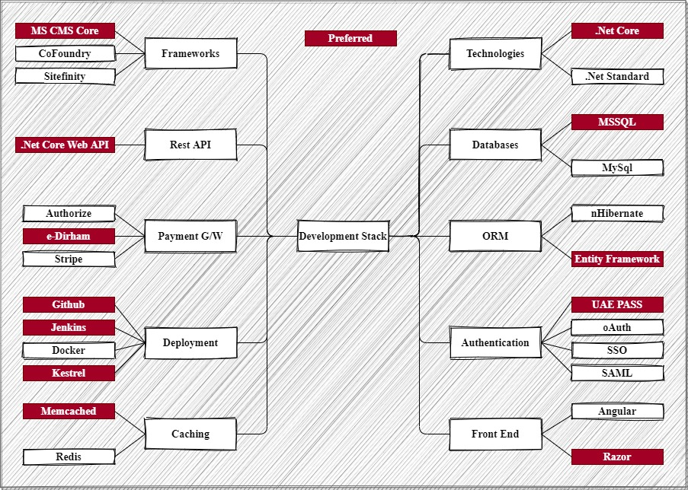

### Technical Architecture

### Architecture Explanation

### QA Tools, processes and release pipelines

### Release & Deployment Pipeline

### Server Topology

### Security Architecture

### Techno-Functional comparison of major .Net CMS platforms

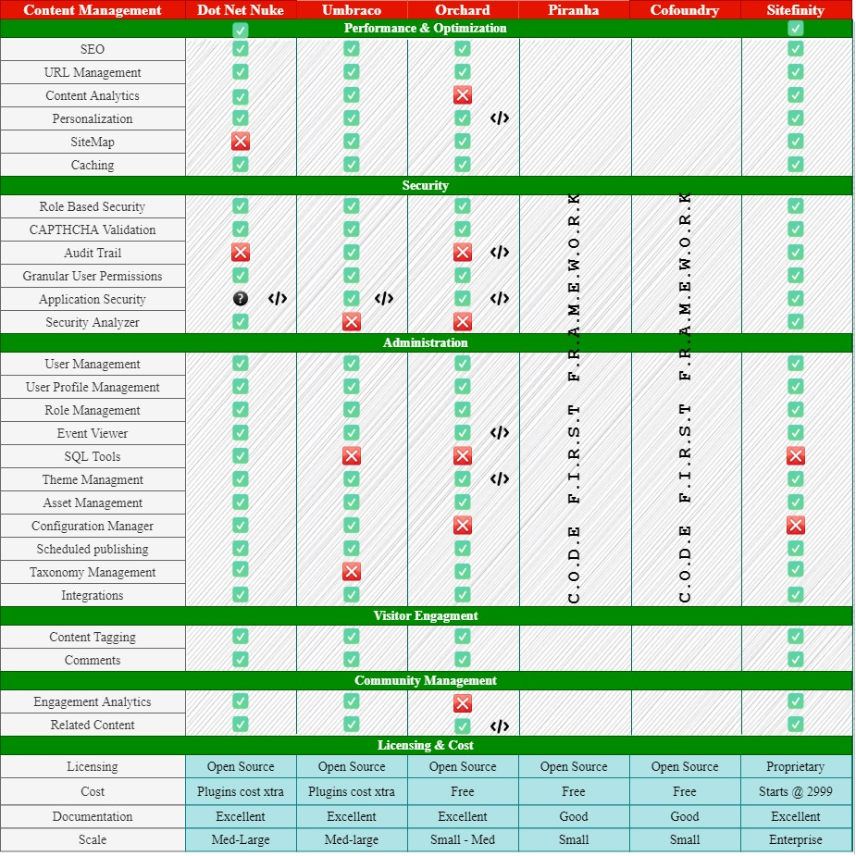

### The Verdict

Proprietary platforms like Sitefinity and Kentico provides a faster route to developing and customizing your CMS. They are relatively bug free and they have an extensive range of features to choose from. However, if you need extensive customization (like creating your business workflows), it does not bestow a huge advantage over open source platforms. But they do have excellent customer support. Typically you would pay a subscription charge north of $2000/month (best guess, not fact)

Umbraco & DNN are the most versatile platforms among the open source platforms. They have paid support plans and you can purchase modules / plugins from their community portal (A lot of them are free, however when you buy a paid plugin, you can be rest assured that it has been well tested and are relatively secure and bug free). It should be noted that not all features are plug and play. As with the proprietary platforms, for custom workflows / forms and business rules there are no short cuts. These platforms have been around since 2003, so they are pretty mature

Orchard stands somewhere in between. It was officially supported by Microsoft in the early days, but no longer. This platform provides a wide variety of features that is common to most CMS platforms, however the philosophy behind the platform leans towards customizations that are more developer centric. Forms and workflows are defined in such a way that it meets certain business goals. Once deployed, they can be customized by an admin within the parameters of the business definition. Community support is not as great as Umbraco or DNN, however it has an active user base and it is supported heavily by Microsoft employees.  All components in Orchard can be replaced or extended. Content is built from easily composable building blocks. Modules extend the system in a very decoupled fashion, where a commenting module for example can as easily apply to pages, blog posts, photos or products. A rich UI composition system completes the picture and ensures that you can get the exact presentation that you need for your content.

Piranha and co-foundry are code first platforms. These platforms provide a robust CMS backbends. These frameworks are intended for applications that require a completely customized UI. The philosophy behind these platforms is that CMS frameworks should not impose restrictions on UI/UX designs. Therefor they provide a minimal UI, just enough to demonstrate its functionality. Obviously, these frameworks require the maximum amount of development effort. Community support is limited for these platforms

All the platforms listed here have a headless implementation option. Headless CMS are light weight implementations without a UI much like the code first platforms.

## FUNCTIONAL REQUIREMENT (OTHERS)

|  |  |
| --- | --- |
| **Requirements** | **Details** |
| User Experience and  UI Design | * The application will be developed only in English * The layout and graphical components will be created considering the usability factors |
| Performance | * Application will allow users to have smooth and quick access to the information or services they require. |
| Security | * Web security standards will be followed. |

## TECHNICAL CONFIGURATIONS

### DEVELOPMENT TOOLS

* React Native
* ASP.Net 4.5
* MS SQL
* HTML5 / CSS 3
* Angular / Razor / Liquid templates
* Web services, Ajax, JavaScript

### RECOMMENDED WEB HOSTING PACKAGE- DEDICATED HOSTING

* Operating System : Windows Server
* CPU : 4 core
* Domains: Unlimited
* Disk Space: 200 GB
* Monthly Bandwidth: 50 GB
* Web site Server Software – IIS 7.5 + / Kestrel
* ASP.NET 4.5

### BROWSER

* Chrome version: 56
* Firefox version: 51
* Internet Explorer:11
* Safari:13

### HARDWARE

The application is reliant on hardware interfaces to provide a seamless automated user experience.

* Computer with Windows 8 or 10 OS
* Compatible Browsers as specified in section 6.2.3
* Samsung galaxy, Iphone 5+, ……

## PROJECT DELIVERY

### PROJECT MANAGEMENT

The Verbat development center strictly follows industry standards on quality. The project management is process governed by the Verbat Quality Management system and is put to verification through internal audit programs that happen from time to time. Verbat will dedicate a project manager for the proposed implementation. Verbat proposes Client to identify one project manager who will be driving activities to be undertaken by Client to be the single point of contact for Verbat.

### ROLES & RESPONSIBILITIES

Verbat will assign a dedicated Project Manager/Project Lead to lead the project, who will be the first point contact for Client. He/she will be responsible for planning and managing the various activities within the project. He/she will work closely with Client Project Manager, to give periodic status updates and ensure high level of visibility and comfort on the progress of the project. The Project Manager/Project Lead will lead the co-ordination between Verbat and Client, thus enabling smooth transitioning of Client requirements to the Verbat ’ offshore delivery team, and provide visibility as well as comfort on the progress of the services to Client.

He/she will have periodic meetings with Verbat ’ s Senior Management, thus ensuring Verbat ’ Management commitment and focus on Client initiatives.

### PROJECT IMPLEMENTATION PLAN

Verbat will be providing the solution in a stand-alone fixed bid approach which ensures minimum viable solution for quick wins with core focus on the long-term business objective and outcome. Once the implementation is over, Verbat will initiate the application maintenance process (once the maintenance contract is signed) which continues to extend after the implementation.

### DELIVERABLES

**Website Deliverables & Timeline**

|  |  |  |  |  |
| --- | --- | --- | --- | --- |
| Phase | Task | Activity | Deliverables | Timeline |
| Discovery & Plan | Stakeholders Workshop | Holding stakeholder workshops via Go to Meeting   * To understand and analyze the wish-list from stakeholders and put them right perspective with the overall project. * To brainstorm ideas, identified challenges, expected KPIs and benchmarks | Stakeholder list or personas (Initial)  Vision Document (feedback, pain points) | 2 days |
| Research customer insights | * Performing user interviews/workshop, based on the user segments identified in the research phase. * Benchmarking MOE against a pre-defined list of competitors and performing a high-level audit of the current website / services. * Creating personas based on analytics and user research * High level review of Google Analytics * Circulating a usability survey to current MOE users via survey monkey and analyzing the results * High level design backlog, template list and Key performance indicators | * Strategy document with consolidated outputs from all of the activities * Updated personas * Competition analysis | 2 days |
| Persona Development & User Journey | Based on research insights, to build personas to convey the user experience challenges to all stakeholders.  This will help to identify the user tasks on the site and pain-points which will define the structure of the site.  Below are the target users (List will be confirmed and defined during the research phase):   * People * Government * Business | User journey and task flows document | 2 days |
| Structure & Prototyping | Information Architecture | Based on the user journey and tasks, create the hierarchy of the site, with segregating content to the right content bucket based on the user's mind map.  Guidelines to be considered while doing the site map:   * Discovery of content by matching user's mind map * Current trends in user's browsing, navigation patterns * Relevance of content & labels with user's mental model. | Site Architecture & Site Map | 2 days |
| Wireframe & FSD (functional specifications document) | Reviewing and providing a new navigation and structure of the interface  Creating wireframes to demonstrate the proposed new flows  Reviewing these flows with the MOE team to ensure alignment until sure  Explain final flow to clarify understanding | Wireframes & FSD | 5 days |
| Prototype and testing with users | With the approved wireframes, create click-through prototype.  The prototype will cover the user journeys The prototype will be testing with real users. The following elements shall be tested   * Navigation * Terminologies & Labels * Structure * User Expectation | * .3 prototypes * Based on the insights the wireframes will be iterated   Deliverables   * Test Guide Document * Analysis Report | 5 days |
| Content | * Based on the identified templates, create content matrix documents, aligning it with the required structure. * MOE will be involved to fill in the sheet with raw content wherever required and collecting and identifying the required assets. | Content Matrix - English & Arabic | 4 days (parallel to other UI/UX activities) |
| Visual Design and UI guide | * Providing and agreeing on visual design guidelines to work with the current MOE guidelines * Creating visual designs based on the approved wireframes * Reviewing all visual designs with the MOE team on a weekly basis to ensure alignment and receive approval | Visual Designs & Style Guide in Sketch | 10 days |
| Implementation Phase | Implement the requirements | * Implementation of new design * Enhance the performance * Implement new pages * Implement the Integration | Deployment on staging | 32 |
| QA testing | Vendor QA shall test the changes and provide all report of different type of testing  (This activity starts well before the official testing phase. So it’s actually much more than 14 days) | * Test cases, Test results, defects report * Performance testing report * Internet browsers compatibility test report | 14 |
| UAT Signoff | Vendor should prepare for UAT test cases and manage the sessions end to end | * UAT test cases * UAT signoff documents with comments if any | 4 |
| Go Live | Prepare for deployment and announcements for Go Live | * Training sessions * Training material * Go live approval document | 1 |
| Closure Phase | PIR | Fix all issues reported after going live and provide list of issues with status and project closure sign off document | * Signoff document of project closure * All technical documents listed All in Deliverables section * Latest Source code * KT technical session to IT team | 5 |

**Web Services Deliverables & Timeline**

|  |  |  |  |  |
| --- | --- | --- | --- | --- |
| Phase | Task | Activity | Deliverables | Timeline |
| Research Framework and Project Preparation | Stakeholder’s workshop | Holding stakeholder workshops online   * Understand and analyze the wish-list from stakeholders and provide the right perspective with the overall project. * To brainstorm ideas, identified challenges, expected KPIs and benchmarks | Vision Document (feedback, pain points, analysis and design vision) |  |
| Research Framework (customer insights) | * Performing user interviews/workshop, based on the user segments identified in the research phase. * Benchmarking MOE against a pre-defined list of counterparts and performing a high-level audit of the existing selected services * Creating personas based on analytics and user research * High level review of services analytics * Circulating a usability survey to current MOE users online and provide insights from the survey outcome | * User testing protocol and report * Strategy document with consolidated outputs from all of the activities |  |
| Persona Development & User Journey | Based on research insights, to build personas to convey the user experience challenges to all stakeholders.  This will help to identify the user tasks on the site and pain-points which will define the structure of the site.  Below are the target users (List will be confirmed and defined during the research phase):   * People * Government * Business | User journey and task flows document |  |
| Service Design & Prototype | Service blueprint | Based on the user journey and tasks, to create the hierarchy of the service, with clear steps, information collection requirements, backend processes and possible scenarios. | Service Architecture & Blueprint to build a prototype |  |
|  | Wireframe & FSD (functional specifications document) | * Providing a new structure of the service design and how customers would approach it * Creating lo-fidelity wireframes to demonstrate the proposed new flows on digital touchpoints * Reviewing these flows with the MOE team to ensure alignment until approvals. * Explain the final flows so the functionality and user flows are clear | Wire frames & FSD |  |
|  | Prototype & testing with Users | * With the approved wireframes, create click-through prototype. * The prototype will cover the user journeys * The prototype will be tested with real users. | * 3 service prototype templates * Based on the insights the wireframes will be iterated   **Deliverables**   * Test Guide Document * Analysis Report |  |
|  | User Interface Development | The selected vendor will work closely with the digital leadership and visual design team to transform the clickable prototypes into a development-ready user interface for implementation | Documentation of the user experience  Implementation Guidelines |  |
|  | UAT Signoff | Vendor should prepare for UAT test cases and manage the sessions end to end | * UAT test cases * UAT signoff document with comments if any |  |
|  | Testing & QA | The vendor will be expected to adjust any service bottlenecks during the QA period after project implementation | Service design corrections and documentation |  |
|  |  |  |  |  |

### DELIVERY ACTIVITY SUMMARY

### ESTIMATED DELIVERY TIME

The effort estimated for delivering the application will be as below:

* 00 UAE working days for the UI/UX from the date of approval of the SRS
* 00 UAE working days for the development of the application from the Date of Approval of the FS.
* The above-mentioned timeline is in UAE Working Days

| **Activity** |
| --- |
| Contract Signoff (T0) |
| Project Initiation & Initiating requirement gathering |
| Software Requirement Specification Document(SRS) |
| SRS Approval (T1) |
| System UI/UX-Complete |
| System UI/UX-Approval (T2) |
| Functional Specification (FS) |
| FS Approval (T3) |
| Development Phase-Complete |
| Perform QC (Unit Testing and Integration Testing) |
| System ready for UAT |
| UAT Acceptance on Verbat server (T4) |

* The initiation of the UI/UX development is dependent on the confirmation of SRS. SRS will be submitted post the confirmation of the project along with LPO, signed proposal and advance payment
* The above mentioned timeline for development is post the confirmation of FS
* Documentation submitted after project initiation and system study supersedes any proposal or documentation submitted during initial requirement gathering / discussion / negotiation
* Project plan will be submitted post the confirmation of project with necessary payments
* Any delay in getting the approvals of deliverables from client will cause change in timelines and the revised timelines will be updated in weekly status reports shared with client after the project commencement
* All approvals and queries regarding the client requirement and any queries which may hinder the project advancement at any stage should be answered by the client within 24 hours from the time of initiation, failing which the time delay will get added to the actual effort and timeline which was estimated.
* On project confirmation, Verbat requires a lead time of minimum seven (07) days for resource mobilization.

### DEPLOYMENT DETAILS (AT CLIENT’S BEHEST)

* Client can opt for hosting the application at Verbat’ Server.
* If deployment is at the client’s server, responsibility of deploying the application onto the production environment after conducting the necessary acceptance testing will lie with the client unless and until Verbat ’ support is contracted for deployment.

### RELEASE PLANNING

* Client will be informed about the release date and time through email.
* Client performs the UAT

### RISK CONTINGENCY PLANNING

Verbat has identified various risk factors associated with this assignment and understands the impact of these risk factors on the project schedules. The objective of this section is to highlight for both Verbat and client, the risk factors, to analyze the impact of the risks on project execution, and to propose strategies to control and reduce the impact of the risk factor. These various risks, which could arise during the project, are tabulated below along with mitigation implementation.

| Type of risk | Impact | Risk Mitigation | Risk Handling |
| --- | --- | --- | --- |
| Scope Creep | H | Functions and features will be detailed in system requirement documents and will go through client approval. Once this document is approved, any change to requirement will go through change management review for possible impact assessment. | Proper change management procedure will be implemented. |
| Delay in customer feedback | H | The plan is prepared with enough lead-time for customer reviews and approvals.  The customer is indicated with the dates when the document is expected after review and approval. | The request for feedback will be escalated if not attended at the right time so that the schedules are not affected. Deemed acceptance criterion is set up front and will be followed. |
| Non-availability of necessary software’s, frameworks, database instances and infrastructure at client’s hosting environment(If hosting support is provided by Verbat ) | M | Client will be informed in advance on these requirements. | Possible impact to schedule. |
| Manpower attrition | L | All efforts would be made to ensure process dependence rather than being person dependent. As a risk mitigation plan Verbat will train backups. | A new person will be identified as early as possible, provided the required project-specific training and mentored by the senior members of the team to minimise impact of attrition on the project. |

*H-High, M-Medium, L-Low, NA-Not Applicable*

## PROJECT ASSUMPTIONS

The project solution and technology is created from the initial understanding of the requirement shared with Verbat through mails and meetings. The proposed solution is based on the following assumptions:

### OBJECTIVE

* The requirement is to develop Corporate Social Innovation Hub with the functionalities as defined in ‘Functional Requirements’ section

### DESIGN

* Client to provide Verbat with the branding guidelines.
* Color theme shall be provided by the client
* Client shall provide licensed images and logos in specified size & format
* Client shall provide the text and associated images for the proposed application. Text should be provided in digital format preferably in MS Word 2013 or above
* Verbat may use template based design for the application

### DEVELOPMENT

* The proposed application front end and backend would be developed in English
* Development Contingent upon timely feedback from client
* The client will finalize the functional requirements and UI/UX before the commencement of the development of the project
* Client shall approve the UI/UX for the web application before development work starts
* Final data needs to be entered by the client via the application
* Client will provide sample data to test the application
* Testing of web application will be done in latest versions of Google Chrome, Mozilla, Edge web browsers only
* Client will procure templates, SSL certificates (if applicable)
* Client will host and manage the application on infrastructure (server / cloud) recommended by Verbat for managing database and application backup inclusive of images
* Application and data backups are subject to the purchase of such services at an extra cost
* Internet connectivity is required for the functioning of the application
* The effort may change after a detailed system study and also after receiving the details of the external components to be integrated
* Payment gateway details would be shared by the client
* **Inline Document Viewer:** Microsoft  office documents cannot be inline as it may require licensed plugins form Microsoft
* **Personalization:** Advanced personalization’s are subject to review and feasibility of implementation
* **Form Builder:** Advanced form builder features depends on the CMS being implemented. Paid and licensed CMS tend to accommodate this feature, but there are no guarantees. Usually there is some development activity that precedes the activation / implementation of a new feature in form builder
* **API Integration:** The client is expected to provide or expose API's related to integrations. API integration requests shall be accompanied by documentation that provides clear, precise & contextual information related to the associated API
* **Site Analytics:** Site analytics shall be implemented using Matomo (Open source) if the CMS package does not provide the functionality. If required, Verbat shall advice the client to procure Google Analytics
* **Performance & Scalability:** A large part of performance and scalability depends on the client’s willingness to invest in appropriate hardware and architecture. Verbat shall provide timely guidelines when needed. Rest assured that Performance, scalability and reliability shall be built into the architecture from ground up.
* **Duplication of Multilingual Conten**t: CMS support for multilingual content without duplication is hard to achieve. Some CMS platforms support Arabic. However this only means that they will translate text used in resources. Ex. Buttons, dialog boxes etc.. This does not mean that they translate custom text messages. Usually .Net uses resource files to do custom translation. Large texts are stored in the database. The only other option is to use a translation service from the big three. There is a subscription charge as well as an additional charge for the amount of text translated for these services. Also, the round trip time over the network should also be accounted for
* **Asset Sharing**: Sharing assets between multiple sites is only possible with the creation of shared services. Assets can be stored and accessed by different pages on the same site.
* **Revisioning**: Revision control is not available for all CMS platforms.
* Unsupported CMS features: Unsupported content or features in CMS platforms need to be developed by customizing the platform.
* **External Social Media Feeds:** Display of external social media content depends on the media's capability to source their content. Sometimes there is a subscription charge associated with this. Again this also depends on the capability of the CMS platform. If unsupported, the feature needs to be developed and incorporated.
* **Template Customization:** Template customization has limits even with the best CMS platforms. Functionality needs to be evaluated before we can confirm all features
* **Workflow Creations and customization:** This is closely related to form building. Not all CMS supports customization of the workflow. Some CMS support the creation of workflows as plugins. Most CMS platforms support publishing workflows by default but business workflows are not supported by all platforms. In either case this feature can be incorporated by customizing the platform.
* **Bulk upload of content**: This is usually a custom feature, that has to be developed separately
* **Mobile App Features:** Busy business workflows are not always easy or practical to replicate on a mobile devices because of limited screen real estate
* **Content Translation:** The client shall be responsible for translating content to Arabic.  The content developed shall be delivered to Verbat in a time sensitive manner that is fit for deployment
* Verbat is a software development company. We do not have the expertise to set the tone for public communication. Neither do we have the expertise or authority to manage the content types (Foundational, evergreen etc.). We expect to be directed by the client in these matters.
* **Competitive research:**  We do not have the expertise to do competitive research. We expect the client to give us direction in identifying the competitors. We shall however do the legwork to identify  and recommend solutions to help assure a stronger footing for our client
* **Content pieces** for topics needs to be provided by the client to develop the creatives. We are assuming that content pieces are text material describing the topic. If this is part of an SEO activity, we may be able to help. But not as part of development.
* **API Services**: The client shall provide / develop / customize all associated API's for the web services. Verbat shall develop the API's for the CMS platform
* Once the templates for the site has been designed and developed, client shall be responsible for creating the content for all template related pages
* **Project delivery timeline WRT. CMS Platform selection:** The **time frame** for the scope of work is heavily dependent on the choice of CMS platform the client decides to implement. We can expect to complete the web site redesign if the client chooses to implement a proprietary platform like sitefinity. The effort and estimate quoted shall vary if the client chooses to adopt an open source platform.
* **Project delivery timeline** is also contingent upon the availability of the client’s stakeholders to conduct meetings in a timely manner that fits the project schedule.
* **Common Backend for website and Mobile:** In case if the CMS platform is proprietary, The API end points may have to be developed separately for mobile apps unless the CMS platform already has a well-documented API back end. ( This is very likely)
* **Employee login:** Since we do not have access to the functions and features of employee login. This proposal does not cover the effort estimate related to this

# **OUT OF SCOPE**

With the ever evolving digital market, the requirement should be clear to both the parties involved, hence the importance of mentioning the out of scope details of the project. Following are considered to be out of scope while creating this proposal:

* Purchase of images, fonts
* Any language other than English
* Migration of existing data / Database migration
* Content writing / proof reading / Data Replication / Manual data entry
* Content or image procurement or uploading or editing
* Audit Trail
* End user testing and load testing
* Developer account creation and Maintenance (Play Store)
* Adding new features to the application other than mentioned in the functional specifications. Such requests will be handled via change management. *For Change management details, please refer section titled “Change Management” in the*
* Annual Maintenance Contract (Bug fixing, debugging, enhancements) – Please refer section titled “Maintenance and Support”, unless contracted for.(refer to section 4.2)
* Hosting Infrastructure and Maintenance (web and email hosting), unless contracted for.
* Application Deployment on the server and respective stores, unless contracted for.
* Backup solution and Disaster recovery unless contracted for.
* Physical deployment onsite / installation of the application in devices and Physical connection, installation of system.
* Integration with third-party, if any, other than mentioned in the functional specifications
* Hardware Integrations / procurement and purchase
* SSL Purchase and installation, if any
* Plugin/template purchases, if any
* OS other than mentioned in the Hardware Interface
* Relevant / related software libraries
* Verbat shall not develop the content pieces for the topics. However we can develop the creatives
* Mobile App Integration: Marketing Automation Software & Analytics Platform (Ex: Google Analytics, CleverTap).
* e-participation – Since you have indicated that this is to be managed by MOE
* The CMS must support NLP architecture.  Why is this a necessity? What is the context? Do you mean to use Natural Language Processing?
* The CMS help contributors flag any potential SEO issues, including missing or poorly formed meta data, H1 headings, missing Alt Tags on images, etc. before a page is published.
* The CMS provide the ability to test each page for broken internal and external links prior to publishing.
* The CMS can identify pages that are missing critical SEO elements.
* Integration with chosen marketing technology for retargeting, automation and engagement for logged in users.
* Features & functionality associated to employee login

## CHANGE MANAGEMENT

Any addition which comes out of the project scope, upon and after the launch of the application will be considered as change management. Verbat recommends the following change management procedure for the same.

* Any change which comes out of the project scope, which was discussed, documented, and mutually approved by both the parties in the requirement stage, will be carried out only through raising a change request.
* Change request will be studied and an impact analysis on the existing work flow will be performed.
* On finalizing the impact, effort estimation for the change will be calculated and raised as additional requirement.
* Verbat will initiate the change request only after getting a formal approval from the client for the additional changes raised.
* Any change from the scope will be charged at AED 1,200.00 per man day effort and approval from the clients will be availed before commencing on any change management.

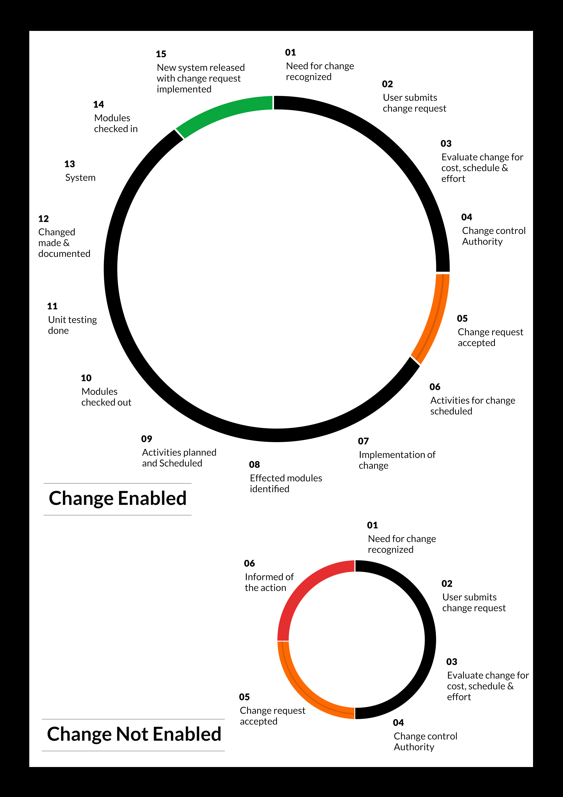

## MAINTENANCE & SUPPORT

* Maintenance contracts by default are supported as per the basic SLA terms.
* AMC with Basic SLA is charged at 25 % of the total project value. Additional Effort/change management request will be added towards Total Value of the Project to determine the AMC value.
* Maintenance support is limited to providing application support for ensuring the consistency of the look-and-feel, bug fixes and user issues i.e. maintenance and support of the existing features of the application.
* Support does not in any way cover providing technical or other support to the end users. The maintenance agreement does not include functionality changes or feature additions which are handled as change requests which will be charged AED 1,200.00 per man day. AMC does not include server support, maintenance and application deployment.
* AMC charges will cover Off-Site Support and Debugging. Support includes E-mail, Telephone and Chat unless explicitly specified. In the event, the application is hosted with the client; necessary remote desktop connectivity should beprovided for carrying out maintenance activity.
* Gap in AMC - In case if the client does not opt an AMC for a year and want to renew it after that period, 50% of the AMC amount for the year for which AMC is not taken will also be payable if the client wishes to renew the AMC contract.

*Note:*

* *Please note that the AMC support shall start only after all the necessary sign-offs (AMC Document) to this effect have been given.*
* *It is not mandatory that the client should opt for an AMC (replace with perhaps: It is mandatory that the client opts for an AMC). The client will still be supported on an ad-hoc basis on an agreed man-day rate.*
* *AMC Payment Terms: 100% to be paid as advance.*

## SERVICE LEVEL AGREEMENT (SLA)

|  |  |  |  |  |
| --- | --- | --- | --- | --- |
| **SLA Type** | **Max Response Time** | | **Max Resolution Time** | **Target** |
| Basic | 1  working day | 3 working days | | Request / incident / problem tickets |
| Advanced | 5 Business Hours | 12 Business Hours | | Request / incident / problem tickets |
| Priority | 3 Business Hours | 5 Business Hours | | Request / incident / problem tickets |

*Note:*

* *We provide Basic SLA as standard with AMC while Advanced and Priority SLAs attract additional charges.*
* *Time zone applicable (8:00 am to 5.00 pm, Sunday to Thursday)*

AMC Option:

Client can opt for time and material based Annual Maintenance, the details of which will be shared post the completion of project.

# **TERMS & CONDITIONS**

## ACCEPTANCE CRITERIA

* UAT (User Acceptance Test) sign off should happen within 07 Days from the first release of the application and the acceptance confirmation needs to be mailed to Verbat failing which Verbat will consider the project as approved by the client.
* Any comments or reason for rejection need to be documented and the same needs to be sent as an email from the official mail id of client to Verbat on or before 07 days from the first release.
* Timeframe for acceptance for any further release will be mutually agreed and finalized between client and Verbat depending on the UAT Comments

## WARRANTY

* Verbat shall provide a bug ﬁx warranty at no additional cost for 30 days from the date of acceptance of the project, for correction of any errors in the developed application that may be attributed to Verbat.
* However, this does not cover modifications by Client, or use of the application on an environment other than the proposed environment, or other circumstances outside Verbat’s reasonable control. In such a case Verbat reserves the right to charge for its services.
* All error corrections will be executed at Verbat India office. In the event of any need for on-site work, all expenses incurred for such trips will be payable to Verbat by Client.

## SOURCE CODE & INTELLECTUAL PROPERTY RIGHTS

* Upon completion of the Project and 100% completion of the payment, client will have access to the source code except for propriety codes, developer tools and third party applications etc.
* The solution offered will be the intellectual property of the client and will be made available to the client on an “unlimited license” basis.
* Modifications by third party/person: No person or organization, other than Verbat or any person authorized by Verbat in writing, has any permission to modify/change the software Solution to be eligible to get continued support from Verbat as per the support terms defined under this document.
* Liabilities/Damages: Verbat accepts no liability or damages of any kind arising out of use or non-use of the software delivered. The responsibility of testing of software lies with Client.

## GENERAL TERMS AND CONDITIONS

* Offer Valid for 30 calendar days from the date of submission of the Proposal.
* An average of 20 working days are assumed in a month.
* All the projects activities will be carried out from our off-shore development center in India
* All the documentation will be provided in English.
* Third party components may be used to develop this application.
* The scope of the project is to develop the Application as detailed in the scope of the project and mentioned in this proposal. Any changes or additions will have to go through change management.
* This proposal would have been derived or concluded from either the RFQ /RFP/data shared via email / information transferred during an initial requirement analysis meeting / tele-conversation. Verbat reserves the right to change the terms of this proposal as the final terms (including the costing), features & functionalities and timeline could change during the course of the project. Hence any fees quoted / timeline committed in this proposal may not be considered as final unless agreed and signed by both parties.
* Web Application will be best viewed only in the environment mentioned in the section Browser Compatibility
* All Source Codes and other project artefacts would adhere to the Verbat document templates and internal coding standards.
* The documents delivered to the client includes the ones mentioned under ‘Deliverables’ and these will adhere to Verbat’s internal document standards.
* Acceptance criteria shall be based on the clauses which were mutually discussed between Verbat and client at the Requirement Analysis phase and the same will be documented and approved by both parties through official emails
* In case Client requires any extension of the proposed acceptance schedule, the associated effort and cost of such extension can be mutually reviewed.
* For any circumstances if project needs to be put on Hold / Stop it requires minimum request notice period of 1 week along with duration for which request will be addressed by management and final decision on the request will be based on that
* If deployment is done in client’s server, Verbat cannot be held responsible for any performance issues arising due to hardware malfunctions.
* Client is responsible for data backup in case the application is not hosted on Verbat server.
* Source code will only be delivered or uploaded on the Production Server once the due payments are made.

## GENERAL ADMINISTRATIVE, TECHNICAL & FUNCTIONAL ASSUMPTIONS

* Detailed system study is required before the start of the project.
* During the requirement gathering phase, authorized personnel from the Client’s side is expected to be available for discussion and finalizing the HLD (High Level Design), before development commences.
* Type of reports and formats, if under the scope of the project, needs to be specified by Client before project sign off.
* Workflows if under the scope of the project, need to be specified/ confirmed by client before project signoff.
* Verbat assumes that all sign-offs from Client will be provided within agreed and specified timeframe.
* Client will provide all the necessary contents, both text and image, before starting the project in the format suggested by Verbat (if any).
* The client should provide the relevant information and data well in time for the execution of a related activity. Non- availability of this information or data may lead to an interruption of work which may result in a delay in delivery as well as additional costs to the client.
* Client should have/possess server with technical specifications as suggested by Verbat for the proposed application.
* Client will be provided with one time training (train the trainer) on how to use the application via video conference (maximum of 4 hours). Additional training requests will be charged.

# **FINANCIALS**

## WEB AND MOBILE APPLICATION DEVELOPMENT

|  |  |  |
| --- | --- | --- |
| **No** | **Description** | **Amount (AED)** |
| 01. | Development of:   * Web Application |  |
|  | **Total Project Cost** |  |

*Note:*

* *The above cost is exclusive of VAT applicable in UAE*
* *The above cost is based on the initial understanding of the requirement grounded on the details shared by client. Any further changes in the scope or complexity if encountered during detailed system study/ analysis will call in for additional effort and time.*
* *The above cost does not include Application hosting, integration with any other third-party systems, deployment unless explicitly mentioned in this proposal.*
* *For feature additions, please refer section titled “Change Management “.*
* *LPO to be raised in the name of “Verbanet Technologies LLC” for project initiation*
* *Refer section 7.3 for ‘Mode of Payment’.*

### PAYMENT TERMS

* 30% () of total project value to be paid as advance along with the Purchase Order
* 40% () of total project value to be paid on confirmation of the UI/UX
* 30% () of the total project value to be paid on completion of Development and UAT on Verbat test server

*Note:*

*Payment should be made within 7 days from the date of invoice.*

## WINDOWS DEDICATED HOSTING – OPTIONAL

ITEM NO. DECSRIPTION AMOUNT (AED)

1. Windows Dedicated Hosting

TOTAL PROJECT COST

*Note:*

* *The above cost is exclusive of VAT applicable in UAE*
* *Refer “Windows Dedicated Hosting Proposal” for detailed Server specifications.*
* *Refer section 7.3 for ‘Mode of Payment’.*
* *LPO to be raised in the name of “Verbanet Technologies LLC” for project initiation*

### PAYMENT TERMS

* 100% advance payment along with Purchase Order to initiate Server purchase

*Note:*

*Payment should be made within 7 days from the date of invoice.*

### MODE OF PAYMENT

By Cheque to Verbanet Technologies LLC

OR

Wire transfer to our bank account

Bank Name : Emirates NBD

Account Name : Verbanet Technologies LLC

Account Number : 1011492858201

IBAN Number : AE61 0260 0010 1149 2858 201

Swift Code : EBILAEAD

Bank Address : Mamzar Branch, Dubai

*Note:*

* *Bank charges incurred during wire transfer to be borne by the client.*
* *Any local taxes / VAT applicable to be borne by the client*
* *Client invoices will include VAT charges in addition to the application cost*

# **CLIENT REFERENCES**

Education

Transportation

**Client Name – Ministry of Education (MOE)**

Organization Name:

Nature of work performed:

Contact person Name:

Telephone Number:

E-mail address:

Project Name: Open Educational Resource Platform (OERP)

Location: Dubai, U.A.E

Ministry of Education has requested Verbat to develop a UAE- Open educational resource platform (OERP). The aim of this platform is to provide a centralized online platform where UAE and others can view, share and contribute their contents. Furthermore, this portal will allow UAE-MOE to track and monitor the progress through a dashboard. All information related to OER such as issue date, source, current state, future state, release dates along with best practices shall be captured.

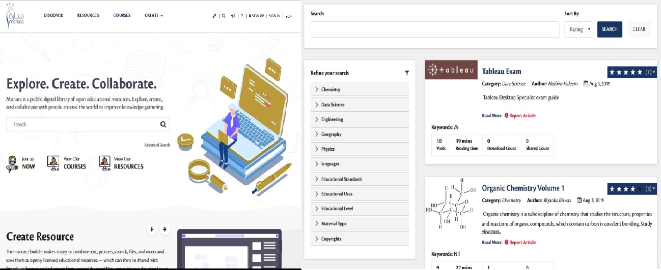

**Client Name – Sharjah Commerce and Tourism Development Authority (Government of Sharjah)**

Organization Name:

Nature of work performed:

Contact person Name:

Telephone Number:

E-mail address:

Project Name: Permit Issuance and Inspection System

Contract Type: Fixed Bid

Location: Sharjah, U.A.E

Established in 1996, the Sharjah Commerce and Tourism Development Authority (SCTDA) is tasked with promoting commercial and tourism activities in the emirate of Sharjah. Sharjah intends to provide a sustainable tourism product with a unique and distinct tourism experience in the desert areas of the emirate. This is geared towards attracting the interest of various tourism companies, specifically tour operators, to focus on Sharjah when organizing desert trips and desert adventures activities within these areas. Consequently, this would be beneficial to the tourism sector and will contribute further to Sharjah’s economy. Hence, the Sharjah government has decided to organize desert tourism activities through this project; the issuance of permits to all tour vehicles entering the desert areas of Sharjah for desert safari activities owned or operated by tour operators along with the day to day inspection tasks carried by inspectors who can issue fines and attach evidences for further actions.

Sharjah Tourism resource deployment model comprises of Offsite resource (Verbat Resource) and Onsite Project Manager (from client’s side)

**Client Name – MBC**

Organization Name:

Nature of work performed:

Contact person Name:

Telephone Number:

E-mail address:

Project Name: Security Inspection System

Contract Type: Fixed Bid

Location: Dubai, U.A.E

Smart Security System facilitates a sophisticated and structured approach to execute the daily security checklist to be used by the security patrol users. In addition to the ability of recording concern/issues as well to be viewed at any time as reports.  The application includes different users like Super Admin, Branch Admin, Inspector, Resolver and Viewer. The Inspector user reports patrol issues and concern issues using android mobile application. Branch admin assign the patrol issues to the resolver. Viewer will be able to see the issues and concerns related to the particular branch.

**Client Name – Carrefour Hybrid Project**

Organization Name:

Nature of work performed:

Contact person Name:

Telephone Number:

E-mail address:

Project Name: Software Quality Assurance Managed Services

Contract Type: Time & Material

Resource Deployment Model: Hybrid (Onsite + Offsite)

Founded in 1992, Majid Al Futtaim is the leading shopping mall, retail and leisure pioneer across the Middle East and North Africa (MENA).

A remarkable business success story, Majid Al Futtaim started from one man’s vision to transform the face of shopping, entertainment and leisure to ‘create great moments for everyone, every day’. It has since grown into one of the United Arab Emirates’ most respected and successful businesses spanning 13 international markets, employing over 27,000 people, and achieving the highest credit rating (BBB) among privately-held corporates in the Middle East.

Carrefour testing team comprised of 20 resources inclusive of Onsite Project Manager, Onsite Test lead and Offsite Test Engineers

**Client Name – Ministry of Foreign Affairs**

Organization Name:

Nature of work performed:

Contact person Name:

Telephone Number:

E-mail address:

Project Name: VISA Scheduling System

Contract Type: Fixed Bid

Location: Dubai, U.A.E

A web based application for the visa applicants and respected sponsors to schedule appointment for the security verifications. The system allows online payment facility. The application features include option for the sponsor to schedule appointments, option for the super admin to manage country and sites, manage other admin users and set e-mail/SMS notifications

# **ABOUT US**

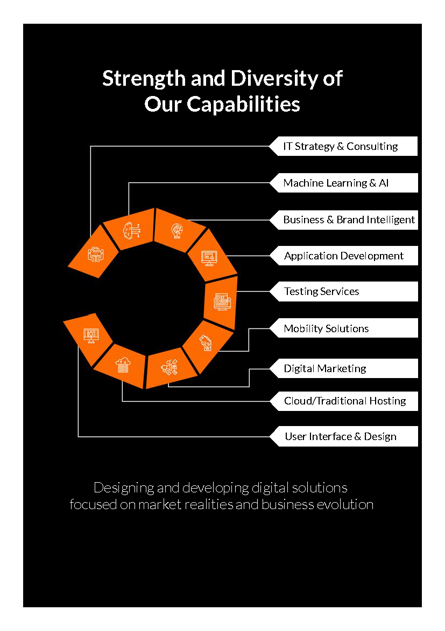

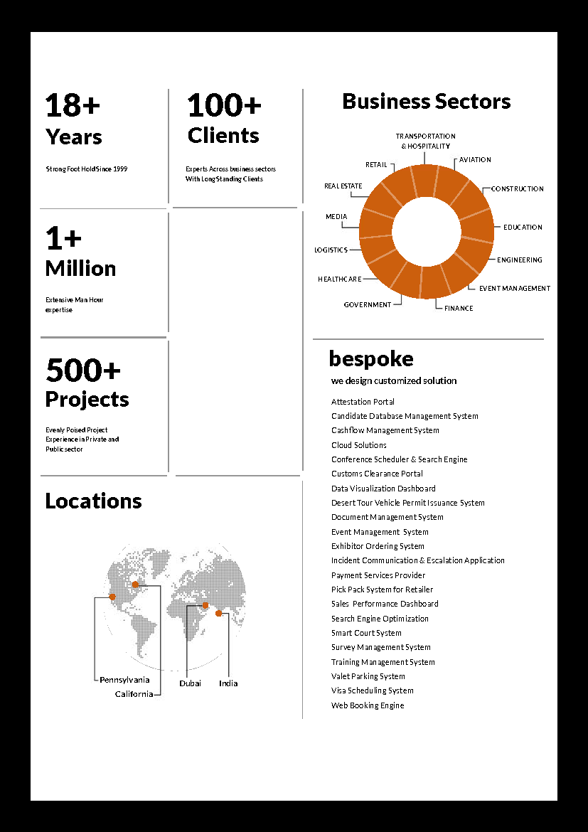

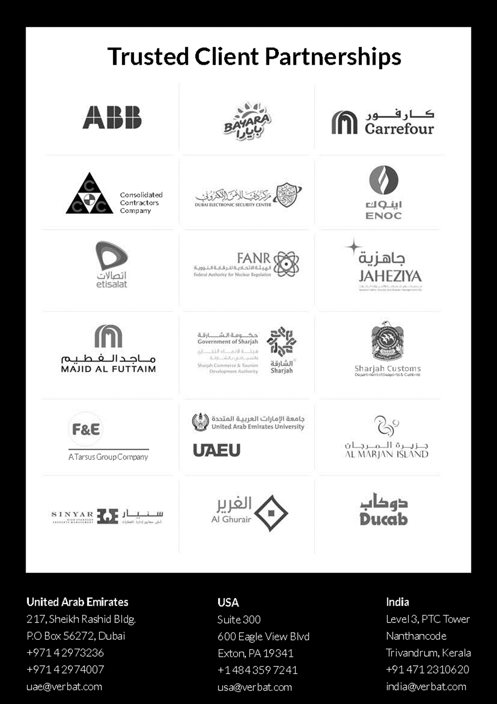

**Conﬁdentiality Notice:**

**This Proposal is conﬁdential and contains proprietary information and intellectual property of Verbanet Technologies LLC. Neither this proposal nor any of the information contained herein may be reproduced or disclosed under any circumstances without the express written permission of Verbanet Technologies L.L.C (hereby known under its brand name of Verbat in the United Arab Emirates). 2018. All rights Reserved**